Contact:
Michael Hicks
Communications Manager 215-343-9241 x123
mhicks@awomansplace.org

For Immediate Release

AWP Names 2016 Honorees

Annual Breakfast & Community Recognition Ceremony thanks Bucks partners striving to end domestic violence

Doylestown, PA (4/22/16) – A Woman’s Place (AWP) of Bucks County will honor community partners, volunteers, and staff members at its annual celebration of those who support AWP and its mission to empower women and end domestic violence.

“Please join us for a hearty breakfast as we acknowledge outstanding individuals and organizations for their invaluable contributions,” says AWP Director of Public Advocacy Heather S. Giampapa. “Their efforts make the Bucks County community a stronger, healthier place for all of us to live and work.”

Responding enthusiastically to the invitation, Donna Foisy with Bucks Promise for Youth and Communities noted that it was a “wonderful honor” to be recognized. Local teen Alekhya Gunturi replied, “Thank you so much for selecting me… it was and still is a pleasure helping A Woman's Place.”

The breakfast will be held at the Northampton Valley Country Club, 299 Newtown-Richboro Road, in Richboro PA from 8:00 to 10:00 a.m. on Thursday, May 19, 2016. Individual guest tickets are $35 and sponsorship opportunities are still available.

Breakfast sponsors include the Law Offices of Michael Kuldiner, Trinity Episcopal Church, Covenant Bank, Huntingdon Valley Bank, Marian Disken, and UNIVEST. Season sponsors include: BlindAlive, Bloomingdale’s, CP Printing Solutions, Doylestown United Methodist Church, Leydon Landscaping, Spark Nonprofit Consulting, and Syngenius.

Remarks by AWP Executive Director, Ifeoma Aduba, will provide an overview of the many programs and initiatives the tremendous support of our community makes possible.

The Keynote Speaker is Peg Dierkers, Executive Director of the Pennsylvania Coalition Against Domestic Violence. During her career, she has directed advocacy, fundraising, and major operations for community-based nonprofits, government institutions, and national commercial businesses.
There will also be a special high-energy music performance by H-Factor of Holicong Middle School under the direction of Jim Glaser, Vocal Musical Director.

Honorees for 2016 are:

- Bucks Promise for Youth and Communities – a countywide coalition whose energetic mission to mobilize, build and strengthen the community around our youth to enrich the quality of life in Bucks County support The Prevention Project of AWP.

- Alekhya Gunturi – a dynamic young woman whose community fundraising efforts have greatly benefited AWP clients and their children.

- Kohl’s Bensalem and Kohl’s Doylestown – store employees have provided dedicated service and volunteerism at AWP events, ensuring a positive experience for attendees and first-rate fundraising to benefit the organization.

- Makefield Women’s Association – a local nonprofit composed of a diverse group of women dedicated to raising funds and providing services to community beneficiaries, whose years of loyal support have made a positive impact in the lives of AWP clients.

- John Ordway – owner of Jules Thin Crust, took it upon himself to lead the restoration efforts at AWP’s emergency shelter and create a warm and comfortable space for those at greatest risk in our community.

- Thompson Toyota – an active community business whose donation of space and services has made great things possible for The Empowerment Project of AWP, clients, and community members.

For more information on this event please visit awomansplace.org/breakfast, call 215.343.9241 x120, or email hgiampapa@awomansplace.org.

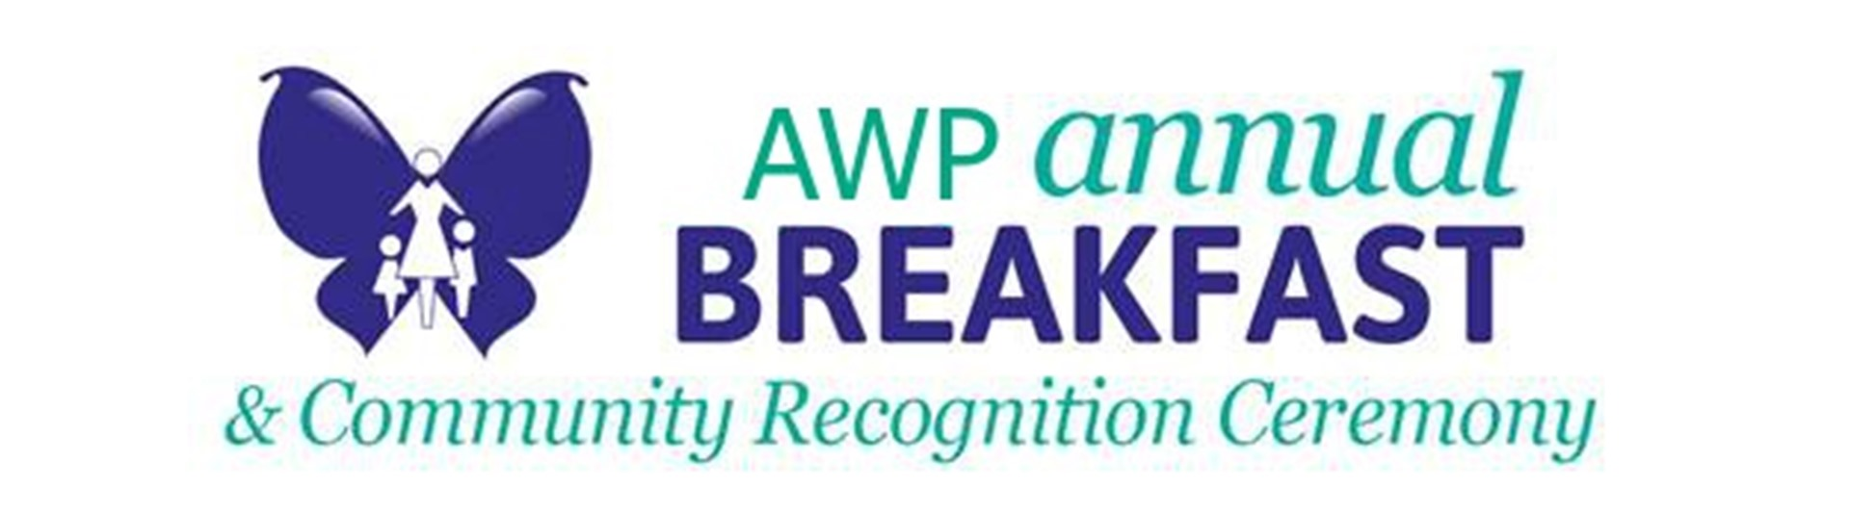

###

About A Woman’s Place
A Woman's Place (AWP) is a community-based social change organization committed to the empowerment of women and to ending intimate and domestic violence for all. For nearly 40 years, AWP has served Bucks County by providing free, confidential, and comprehensive services and support to victims of domestic violence, their children, and the community. AWP’s hotline (1.800.220.8116) is available 24/7 for victims, community members, donors, or volunteers. Visit www.awomansplace.org for more info.

